**COA LAB**

**Experiment – 3**

**Problem Statement**: Write an assembly language program to compute factorial for a given number.

**Algorithm**:

**Step 1**: Define the Base Register Address value during the creation of the program

**Step 2**: Move the operand to Register R1 for which you need to find out the factorial

**Step 3**: Move the Register R1 value to the R0

**Step 4**: Move the value 1 to Register R2

**Step 5**: Create a label named ‘factorial’

**Step 6**: Multiply Register R1 with register R2 and store result in R2 register

**Step 7**: Decrement Register R1 value

**Step 8**: Compare Register R1 with value 1

**Step 9**: If the Register R1 is greater than 1, jump to the ‘factorial’ label

**Step 10**: If the Register R1 is lower than or equal to 1, store the resultant factorial value in the memory location

**Step 11**: Halt the simulator

**Assembly Language code:**

**MOV #5, R01** *;Store value of 5 in register R01*

**MOV R01, R00** *;Move register R01 value to R00.*

**MOV #1, R02** *;Store value of 1 in register R02*

**factorial:** *;Label for factorial*

**MUL R01, RO2** *;Multiply registers RO1 to R02 and store the resultant value in register R02*

**DEC R01** *;Decrement register R01 value by 1*

**CMP #1, R01** *;Compare register R01 value by 1*

**JGT $factorial** *;If register R01 value is greater than 1, jump to the 'factorial' label*

**STB R02, 0** ;*Store register R02 value in memory location 0*

**JLT 35** *;If register R01 value is less than or equal to 1, jump to the statement of Padd 35*

**HLT** *;Stop the simulator*

**Result**: 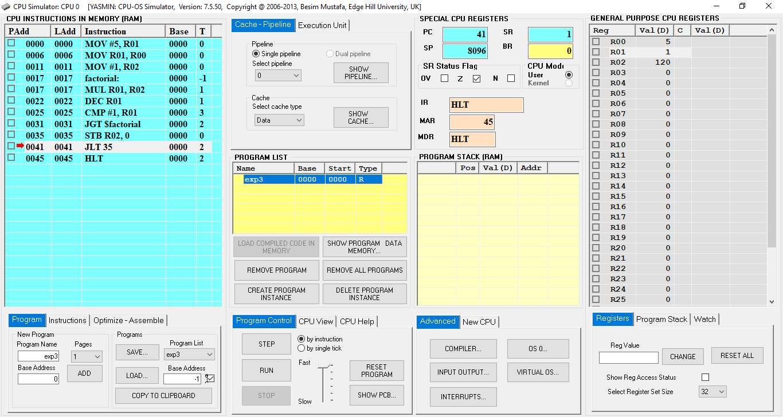

**Fig. 1**: CPU Simulator Window

**Fig. 2**: Data Memory Window